Java OOPS concept Assignment
Q1.
package JavaAssignment1;
class Employee
{
private int empId;
private String empName;
private float salary;
public int getEmpId() {
return empId;
}
public void setEmpId(int empId) {
this.empId = empId;
}
public String getEmpName() {
return empName;
}
public void setEmpName(String empName) {
this.empName = empName;
}
public float getSalary() {
return salary;
}
public void setSalary(float salary) {
this.salary = salary;
}
void displayDetails(int empId,String empName,float salary)
{
System.out.println(empId+ " "+empName+ " "+salary);
}

}
public class EncapsulationAss1 {

public static void main(String[] args) {
Employee obj=new Employee();
obj.displayDetails(1234,"Harish",3000000);

}

}
Output:
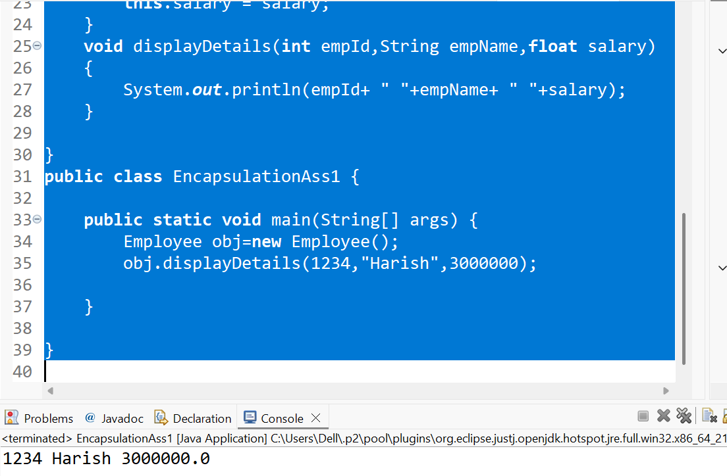
Q2.
package JavaAssignment1;
class Vehicle
{
void fuelType()
{
System.out.println("Runs on fuel");
}
}
class ElectricCar extends Vehicle
{
void fuelType()
{
System.out.println("Runs on electricity");
}
}
public class InheritanceQ2 {

public static void main(String[] args) {
Vehicle v=new Vehicle();
v.fuelType();

ElectricCar e=new ElectricCar();
e.fuelType();
}

}
Output:
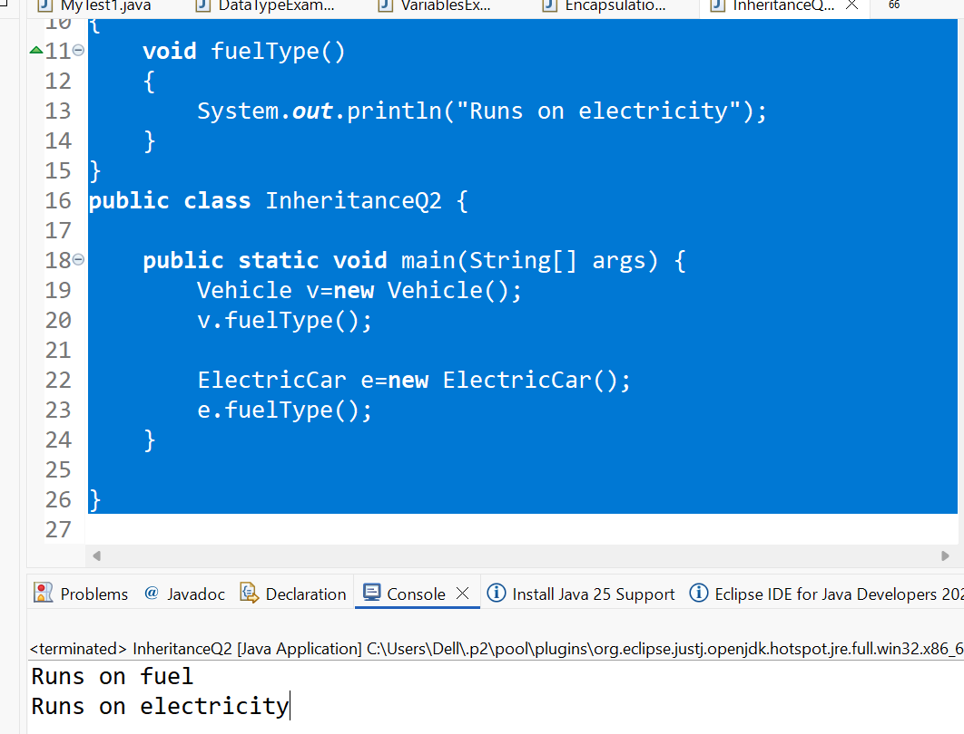
Q3:
package JavaAssignment1;
class Product
{
int productId;
String productName;
float price;

Product()
{
System.out.println("Product Created");
}
Product(int productId,String productName,float price)
{
this.productId=productId;
this.productName=productName;
this.price=price;
}
void display()
{
System.out.println(productId+" "+productName+" "+price);
}
}
public class ConstructorOverridingQ3 {

public static void main(String[] args) {

Product p=new Product();
Product p1=new Product(1234,"Jhon",7000000f);
p1.display();

}

}
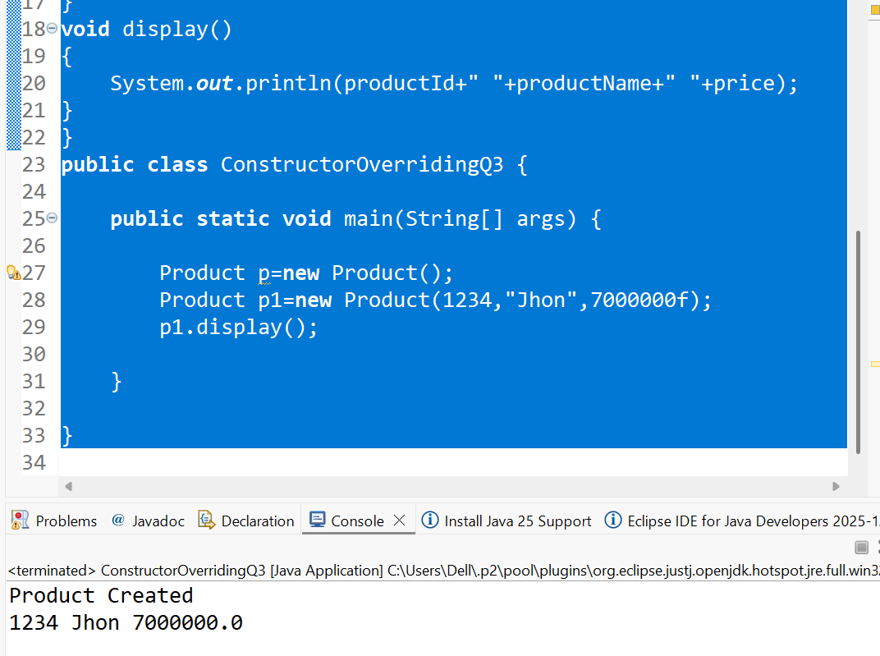
Q4:
package JavaAssignment1;
class Calculator
{
int add()
{
return 0;
}
int add(int a,int b)
{
return a+b;
}
double add(double a, double b)
{
return a+b;
}

}
public class MethodOverloadingQ4 {

public static void main(String[] args) {
Calculator calc=new Calculator();
System.out.println(calc.add());
System.out.println(calc.add(12,15));
System.out.println(calc.add(12.5,163.6));

}

}
Output:
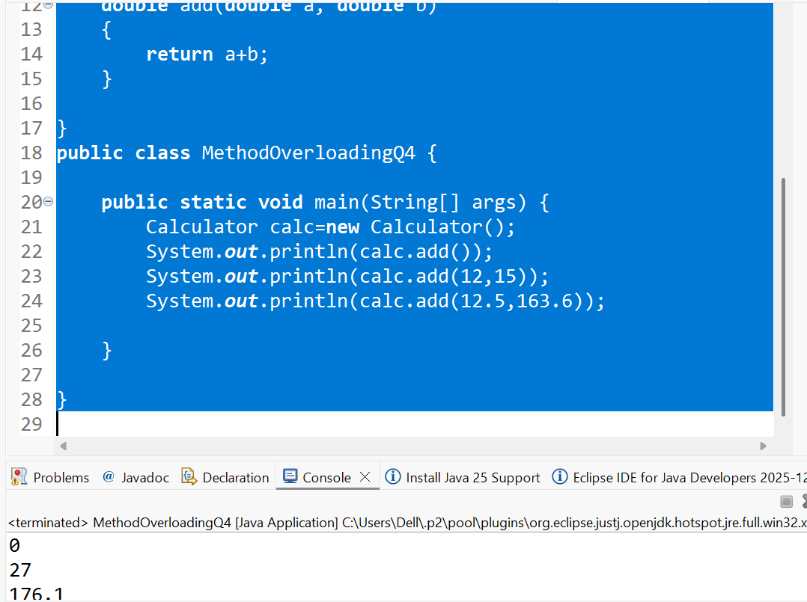

Q5:
package JavaAssignment1;
abstract class Animal
{
abstract void sound();
{
System.out.println("Sound of the Animals");
}
}
class Dog extends Animal
{
void sound()
{
System.out.println("Dog barks: Woof Woof!");
}
}

class Cat extends Animal
{
void sound()
{
System.out.println("Cat meows: Meow Meow!");
}
}

public class AbstractionAss5 {

public static void main(String[] args) {
Cat obj = new Cat();
obj.sound();
Cat obj1 = new Cat();
obj1.sound();
}

}
Output:

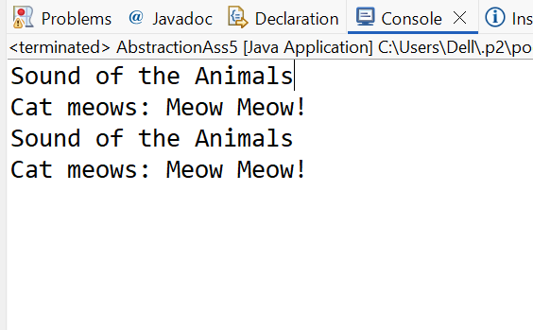
Q6:
package JavaAssignment1;
interface Payment
{
void makePayment();

}

class UPI implements Payment
{
public void makePayment()
{
System.out.println("Enterd UPI is correct");
}
}
class CreditCard implements Payment
{
public void makePayment()
{
System.out.println("Enterd credit card number is correct");
}
}
public class Interfaceimplementation6 {

public static void main(String[] args) {

Payment ref=new CreditCard();
ref.makePayment();
Payment ref1=new UPI();
ref1.makePayment();
}

}
Output:
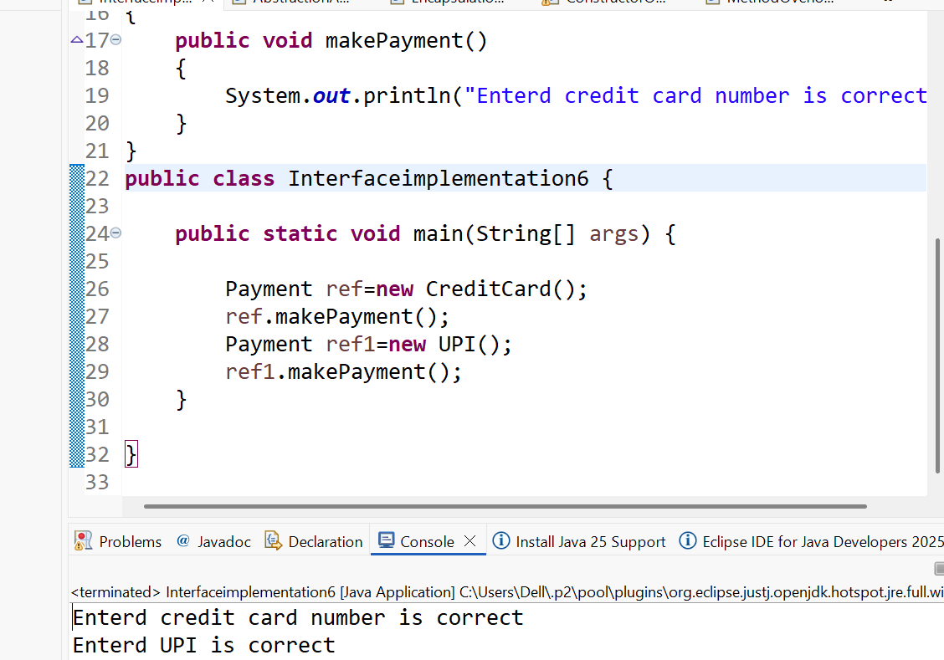
Q7:
package JavaAssignment1;
class Person
{
Person()
{
System.out.println("Person Created");
}
}
class Student extends Person
{
Student()
{
super();
System.out.println("Student Created");
}

}
public class UseOfSuperKeywordQ7 {

public static void main(String[] args) {
Student Std=new Student();

}

}
Output:
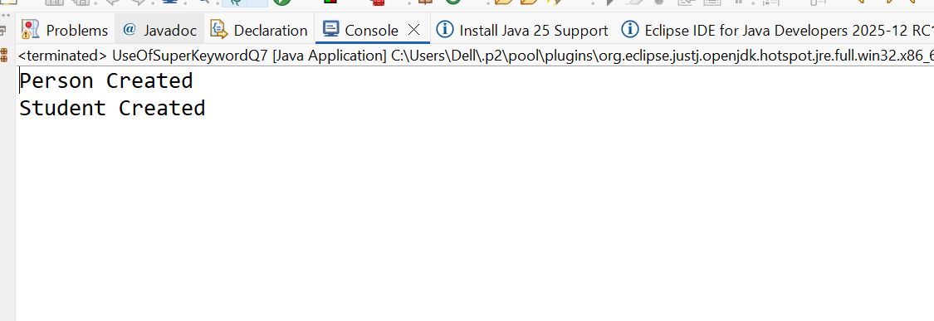

Q8:
package JavaAssignment1;

class Shape
{

double area()
{
return 0;
}
}
class Rectangle extends Shape
{
double length=45.6;
double breadth=87.45;
double area()
{
return length*breadth;
}
}

class Circle extends Shape
{
double pi=3.14;
double Radius=12.67;
double area()
{
return pi*Radius*Radius;
}

}
public class DynamicBindingQ8 {

public static void main(String[] args) {
Rectangle Rect=new Rectangle();
System.out.println(Rect.area());

Circle Cir=new Circle();
System.out.println(Cir.area());

}

}
Output:
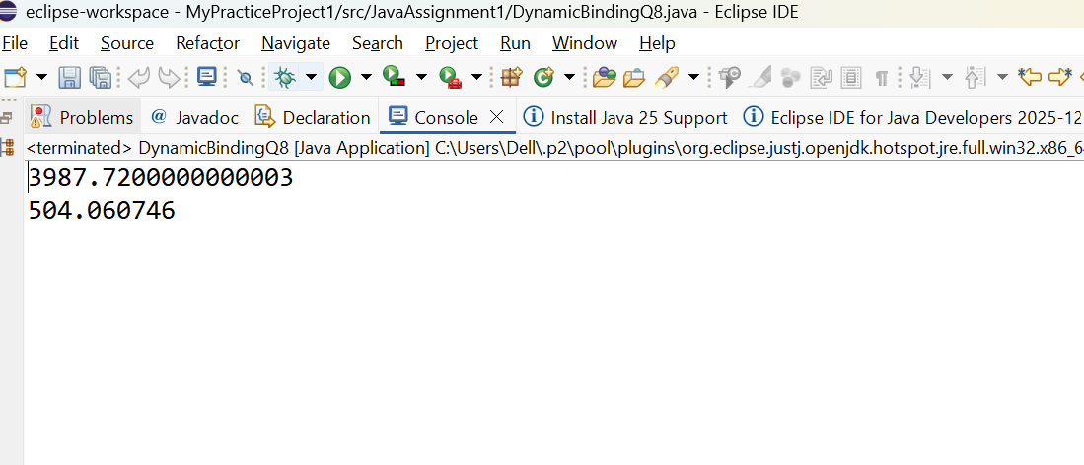
Q9
package JavaAssignment1;
class Bank
{
final String IFSC="BANK7890000";
final void showIFSC()
{
System.out.println("IFSC code is:" +IFSC);
}
}
class HDFCBank extends Bank //overriding Bank
{
void showIFSC()//Compile time error,Final method can't be overridden
{

System.out.println("IFCS code is:" +IFSC);
}
}
public class FinalKeywordQ9 {

public static void main(String[] args) {

Bank b=new Bank();
b.showIFSC();

HDFCBank B1=new HDFCBank();
B1.showIFSC()

}

}

Output:

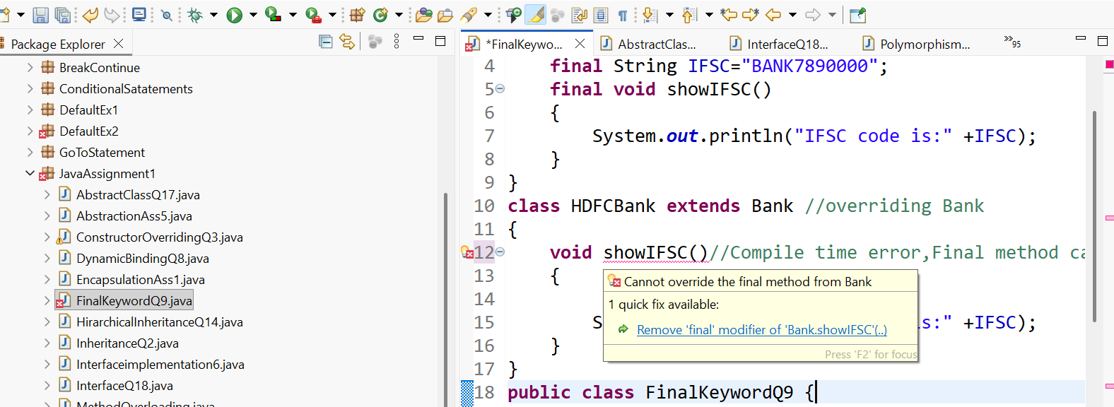

Q10
package JavaAssignment1;
class Student1
{
static String collegeName ="BMSIT";
String name ;
int rollNo;

Student1(String Name,int RollNo)
{

name=Name;
rollNo=RollNo;
}
void display()
{
System.out.println(collegeName+" "+name+" "+rollNo);
}
}
public class StaticKeywordQ10 {

public static void main(String[] args) {
Student1 Std=new Student1("Saras",123);
Std.display();

Student1 Std1=new Student1("Anand",124);
Std1.display();

Student1 Std3=new Student1("Bindu",125);
Std3.display();

Student1 Std4=new Student1("Jhon",126);
Std4.display();

}

}
Output:

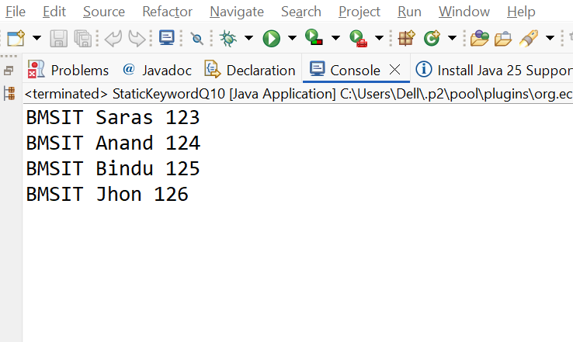

Q11:
package JavaAssignment1;
class Library
{
String libraryName;

Library()
{
System.out.println("Welcome to the Library!");
}
void showLocation()
{
System.out.println("This library is located in Mumbai");
}

}
public class Question11 {

public static void main(String[] args) {

Library L=new Library();
L.showLocation();
}

}

Output:
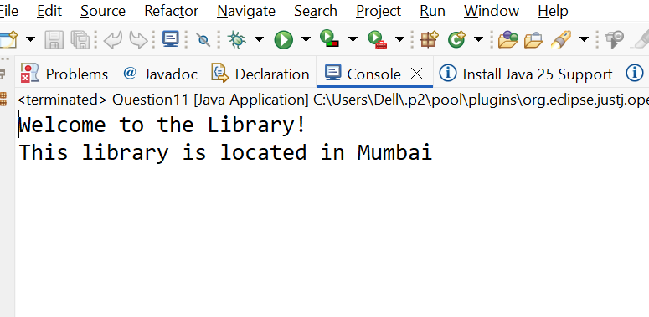

Q12
package JavaAssignment1;
class Account
{
private String accountHolderName ;
private double balance;
public String getAccountHolderName() {
return accountHolderName;
}
public void setAccountHolderName(String accountHolderName) {
this.accountHolderName = accountHolderName;
}

public double getBalance() {
return balance;
}
public void setBalance(double balance) {
if(balance<0)
{
System.out.println("balance should not accept negative values");
}
else
{
this.balance = balance;
}

}

}
public class Question12 {

public static void main(String[] args) {
Account acc=new Account();
acc.setAccountHolderName("Anand Kumar");
acc.setBalance(30000);
acc.setBalance(-4800);

System.out.println(acc.getAccountHolderName());
System.out.println(acc.getBalance());
}

}
Output:

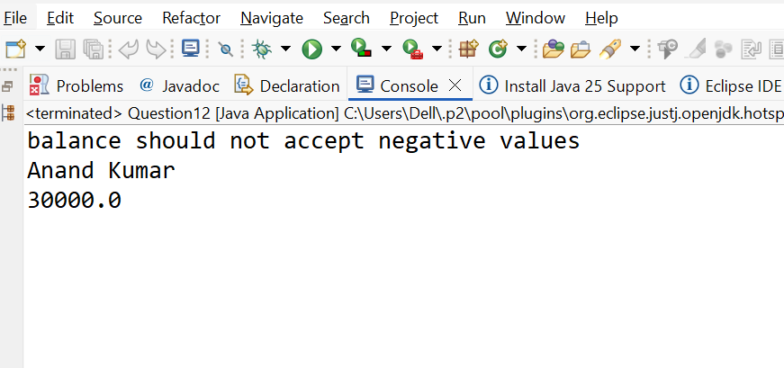
Q13:
package JavaAssignment1;
class Device
{
void Start()
{
System.out.println("ON the device");
}
}
class Mobile extends Device
{
void calling()
{
System.out.println("Calling to the mobile");
}
}
class SmartPhone extends Mobile
{
void internet()
{
System.out.println("Allow internet access to smartphone");
}
}
public class MultipleInheritanceQ13 {

public static void main(String[] args) {

SmartPhone sp=new SmartPhone();
sp.Start();
sp.calling();
sp.internet();

}

}

Output:
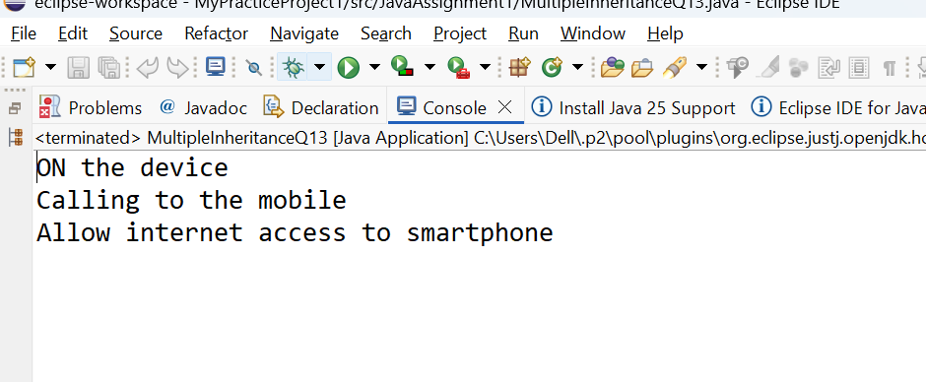

Q14:
package JavaAssignment1;
class Course
{
void courseInfo()
{
System.out.println("This course includes Science,Commerce and Arts");;
}
}
class Science extends Course{
void ScienceCourse()
{
System.out.println("Science course covers Physics,chemistry and biology");
}
}
class Commerce extends Course{
void CommerceCourse()
{
System.out.println("commers course covers Accounting,Business Studies");
}
}
class Arts extends Course
{
void ArtsCourse()
{
System.out.println("Arts course covers History,Political science");
}
}
public class HirarchicalInheritanceQ14 {

public static void main(String[] args) {
Course c=new Course();
c.courseInfo();

Science sc=new Science();
sc.ScienceCourse();

Commerce cm=new Commerce();
cm.CommerceCourse();

Arts ar=new Arts();
ar.ArtsCourse();

}

}
Output:
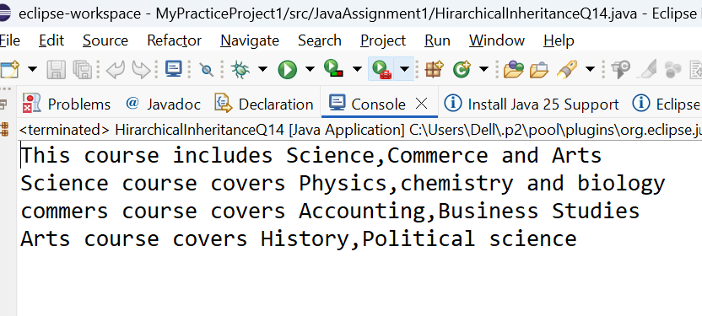
Q15:

package JavaAssignment1;
class LoanCalculator1
{
void calculateLoan(int amount)
{
double interestRate=5.6;
double interest=amount*interestRate/100;
double Total=amount+interest;
System.out.println("Loan amount is :" +amount);
System.out.println("Loan interest is :"+interest +"%");
System.out.println("Total payable amount is :" +Total);
}
void calculateLoan(int amount, double interestRate)
{

double interest=amount*interestRate/100;
double Total=amount+interest;
System.out.println("");
System.out.println("Loan amount is :" +amount);
System.out.println("Loan interest is :"+interestRate +"%");
System.out.println("Total payable amount is :" +Total);
}
}
public class MethodOverloadingQ15 {

public static void main(String[] args) {

LoanCalculator1 lc=new LoanCalculator1();
lc.calculateLoan(3000000);
lc.calculateLoan(2000000, 10);
}

}
Output:
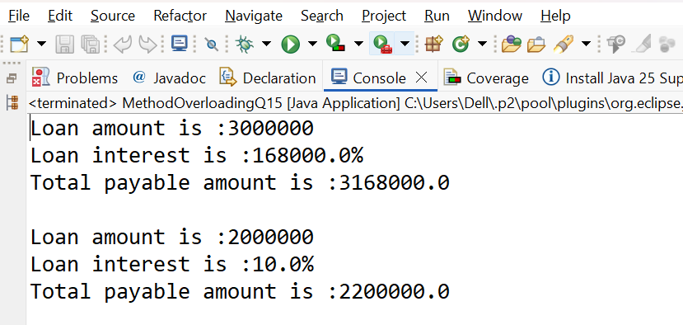

Q16:
package JavaAssignment1;
class Hospital
{
void emergencyService()
{
System.out.println("Service is available 24/7");
}
}
class CityHospital extends Hospital
{
void emergencyService()
{
super.emergencyService();
System.out.println("Cityhospitals as advanced emergencyservice");

}
}
public class MethodOverridingQ16 {

public static void main(String[] args) {
CityHospital ch=new CityHospital();
ch.emergencyService();
}

}

Output:
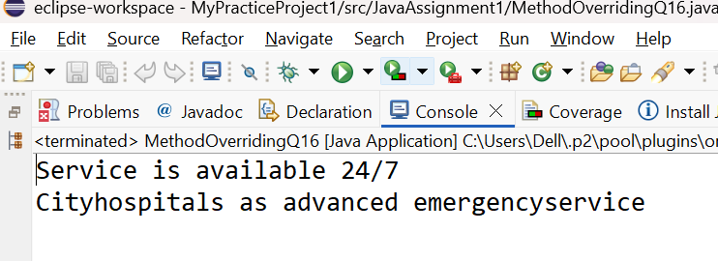

Q17
package JavaAssignment1;
abstract class Employee1
{
String EmpName;

abstract double calculateSalary();

void employeeDetails()
{

System.out.println("Employee name is:"+EmpName );
}

}
class FullTimeEmployee extends Employee1
{
double Salary;
FullTimeEmployee(String EmpName,double Salary)
{
this.EmpName=EmpName;
this. Salary=Salary;

}

double calculateSalary()
{
return Salary;
}
}
class PartTimeEmployee extends Employee1
{

int hour;
double Salary;
double rate;
PartTimeEmployee(String EmpName,double rate,int hour)
{
this.EmpName=EmpName;
this.rate=rate;//rate is a salary paid for 1 hour
this.hour=hour;
}

double calculateSalary()
{
return rate*hour;
}
}
public class AbstractClassQ17 {

public static void main(String[] args) {
Employee1 fe= new FullTimeEmployee("Anand",3000000);
fe.employeeDetails();
System.out.println("Salaryis:"+fe.calculateSalary());
System.out.println("");
Employee1 pe=new PartTimeEmployee("Bindu",100,24);pe.employeeDetails();
System.out.println("Salaryis:"+pe.calculateSalary());
}

}

Output:
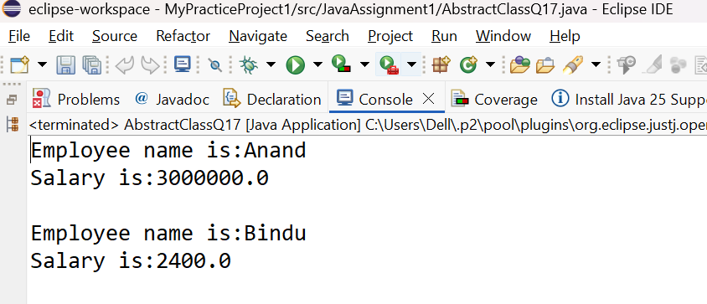

Q18:
package JavaAssignment1;
interface Transport
{
void booking();
}

class Bus implements Transport
{
public void booking() {
System.out.println("Bus is booked");

}

}
class flight implements Transport
{
public void booking()
{
System.out.println("flight is booked");

}
}
public class InterfaceQ18 {

public static void main(String[] args) {
Transport ref=new Bus();
ref.booking();

Transport ref1=new flight();
ref1.booking();

}

}
Output:
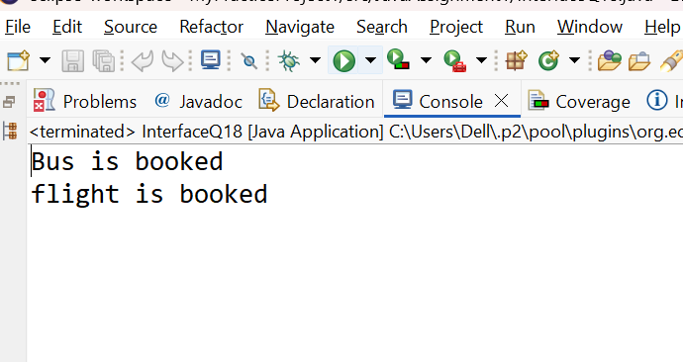
Q19
package JavaAssignment1;
class Camera
{
void capture()
{
System.out.println("Capture the photo");
}
}
class DSLCamera extends Camera
{
void capture()
{
System.out.println("Well advanced option to capture the photo");
}
}
public class PolymorphismRunUPQ19 {

public static void main(String[] args) {
Camera c=new DSLCamera();
c.capture();
}

}

Output:
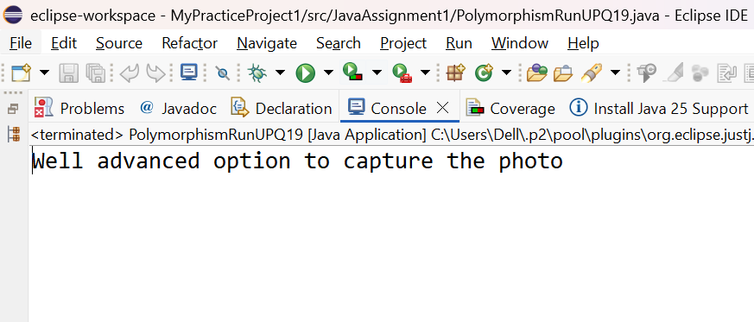
package JavaAssignment1;
class Camera
{
void capture()
{
System.out.println("Capture the photo");
}
}
class DSLCamera extends Camera
{
void capture()
{
System.out.println("Well advanced option to capture the photo");
}
}
public class PolymorphismRunUPQ19 {

public static void main(String[] args) {
Camera c=new DSLCamera();
c.capture();
}

}
Output:
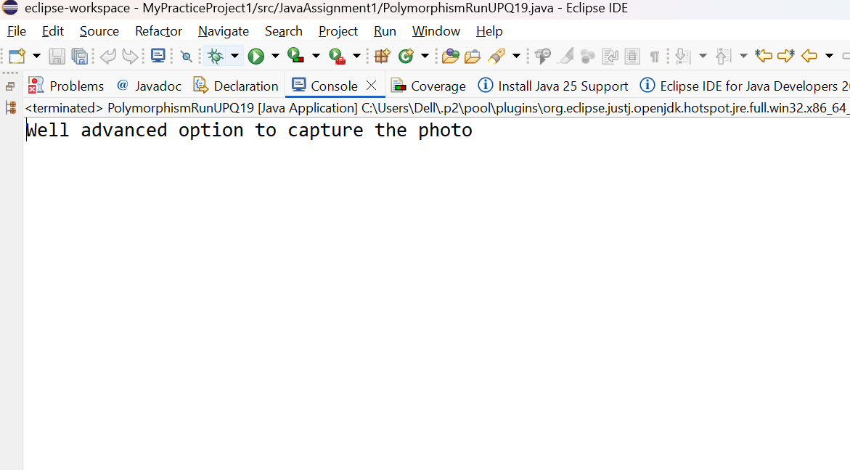

Q21:
package JavaAssignment1;
class University
{
static String country ="India";
String universityName;
University(String universityName )
{
this.universityName=universityName;
}
void display()
{
System.out.println("University name is:"+universityName);
System.out.println("Country name is:"+country);
System.out.println();
}
}
public class StaticConceptQ21 {

public static void main(String[] args) {
University ur=new University("VTU");
ur.display();

University ur1=new University("Banglore");
ur1.display();
}

}

Output:
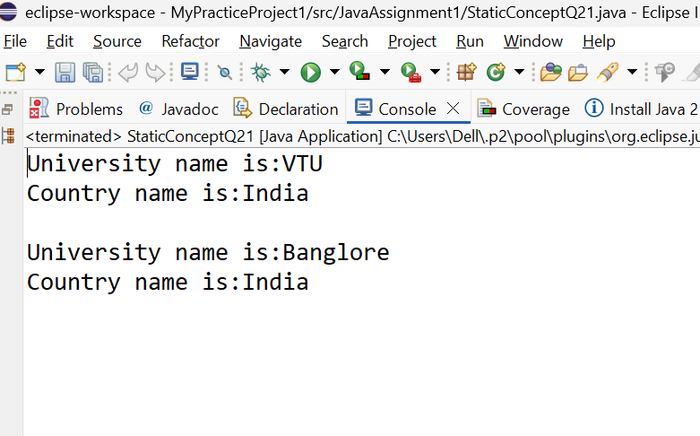

Q22
package JavaAssignment1;
class GovernmentRules
{
final int MAX_WORKING_HOURS = 8;
/* void display()
{
MAX_WORKING_HOURS=10;
}*/

}

public class FinalQ22 {

public static void main(String[] args) {
GovernmentRules gr=new GovernmentRules();
gr.MAX_WORKING_HOURS=10;

}

}

Compile time error:
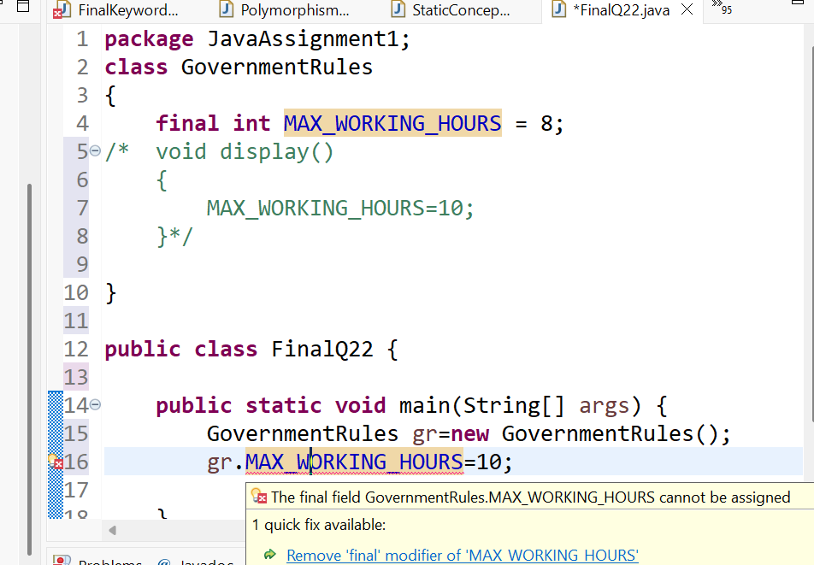

Q23

package JavaAssignment1;
class Mall
{
Mall ()
{
System.out.println("Welcome to the Mall");
}
Mall(String ShopName)//Parameterized constructor
{
this();//calling default constructor
System.out.println("Shop name is:"+ShopName);
}
}
public class ConstructorChaining23 {

public static void main(String[] args) {

Mall m=new Mall("Biba");
}

}
Output:
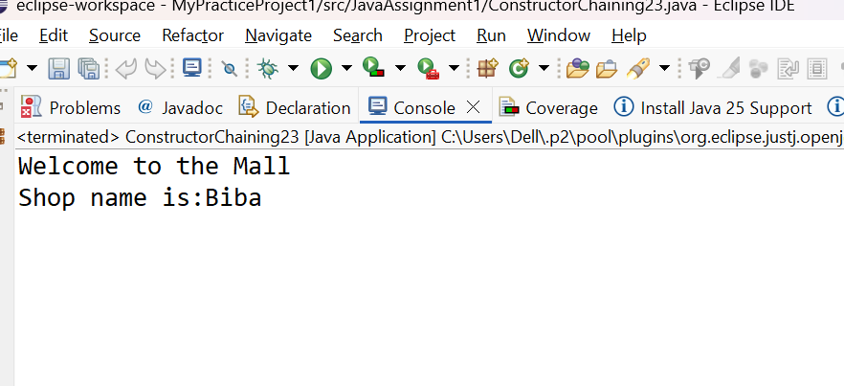
Q24
package JavaAssignment1;
class Shape1
{
final double pi=3.14;
float length;
void square ()
{
float area=4*length;
System.out.println("Area of the square is:" +area);
}
void rectangle(float breadth)
{
float area=length*breadth;
System.out.println("Area of the rectangle is:" +area);
}
void circle()
{

double area=pi*length*length;
System.out.println("Area of the circle is:" +area);
}
}

public class ShapeQ24 {

public static void main(String[] args) {
Shape1 s=new Shape1();
s.length=8;
s.square();
s.rectangle(6.7f);
s.circle();

}

}
Output:
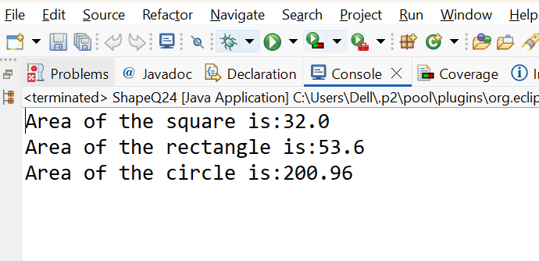
Q25
package JavaAssignment1;
class school
{
String name;
school()
{
name="Oxford";
System.out.println("Name of the school is: " +name);
}
void display()
{
System.out.println("This School is based out of Kolkata");
}
}
public class ConstructorMethodsQ24 {

public static void main(String[] args) {
school s=new school();

s.display();

}

}

Output:
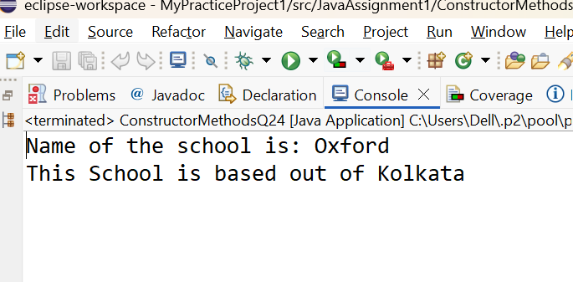
Q26
package JavaAssignment1;
class school1
{
String name;
String address;
int Streangth;

school1(String name,int Streangth)
{
this.name=name;
this.Streangth=Streangth;
this.address="Banglore";

}
school1(String name,String address,int Streangth)
{
this.name=name;
this.address=address;
this.Streangth=Streangth;

}
void display()
{
System.out.println("name of the school:" +name);
System.out.println("Address of the school:" +address);
System.out.println("Streangth of the school:" +Streangth);
System.out.println();
}
}
public class VariableConstructorMethodQ26 {

public static void main(String[] args) {
school1 s=new school1("AML School", 32);
s.display();

school1 s1=new school1("Oxford","delhi", 60);
s1.display();

}

}
Output:
